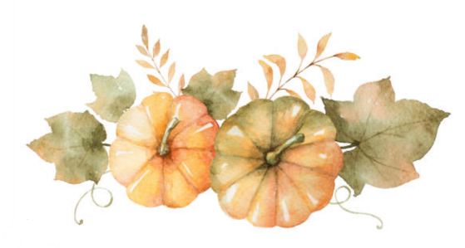  thanksgiving Pairing  with 1723 Vineyards  Alta White Blend  2023  pineapple & cream, mango, floral and earthy notes  Oaked Rosé  2022  orange peel, cranberry, rhubarb  Chambourcin  2021  cherry, tea leaf, white pepper, red raspberry | thanksgiving Pairing  with 1723 Vineyards  Alta White Blend  2023  pineapple & cream, mango, floral and earthy notes  Oaked Rosé  2022  orange peel, cranberry, rhubarb  Chambourcin  2021  cherry, tea leaf, white pepper, red raspberry
thanksgiving Pairing  with 1723 Vineyards  Alta White Blend  2023  pineapple & cream, mango, floral and earthy notes  Oaked Rosé  2022  orange peel, cranberry, rhubarb  Chambourcin  2021  cherry, tea leaf, white pepper, red raspberry | thanksgiving Pairing  with 1723 Vineyards  Alta White Blend  2023  pineapple & cream, mango, floral and earthy notes  Oaked Rosé  2022  orange peel, cranberry, rhubarb  Chambourcin  2021  cherry, tea leaf, white pepper, red raspberry

